____________________________________________________________________________

Status of code / additional notes
Points / descriptions to check
Priority to check
Choice (to re-visit later or after writing code in full)
Checks
Code snippets

____________________________________________________________________________

Text file with information about Deltas (COMPLETE)

Table of:
Delta, Mc_SLN, Mp_SLN, sigma_LN, sigma_SLN, alpha_SLN, alpha_CC3, beta

Isatis runs

Unmodified version
- Monochromatic MF

____________________________________________________________________________

START OF PROGRAM:

Imports:
- numpy
- matplotlib.pyplot
- matplotlib

Plotting style code

____________________________________________________________________________

METHODS:
- LN (m, m_c, sigma) INITIAL IMPLEMENTATION
  - Log-normal mass function (with characteristic mass m_c and standard deviation sigma), evaluated at m.
  - m:
    - Array-like. PBH mass.
  - m_c:
    - Float. Characteristic PBH mass
  - sigma:
    - Float. Standard deviation of the log-normal mass function.
  - Returns:
    - Array-like: Value of the log-normal mass function.

- SLN (m, m_c, sigma, alpha) INITIAL IMPLEMENTATION
  - Skew-lognormal mass function (defined in 2009.03204 Eq. 8]), with characteristic mass m_c and parameters sigma and alpha, evaluated at m.
  - m: Array-like.
    - PBH mass.
  - m_c: Float.
    - Characteristic PBH mass.
  - Sigma: Float.
    - Parameter relates to width of skew-lognormal mass function.
  - alpha: Float.
    - Parameter controls the skewness (alpha=0 reduces to a lognormal).
  - Returns:
    - Array-like: Value of the skew-lognormal mass function.

- CC3 (m, m_p, alpha, beta) INITIAL IMPLEMENTATION
  - Critical collapse 3 mass function (defined in 2009.03204 Eq. 9), with peak mass m_p and parameters alpha and beta, evaluated at m.
  - m: Array-like
    - PBH mass.
  - m_p: Float
    - Peak mass.
  - Alpha: Float
    - Controls location and shape of low-mass tail
    - This description comes from bullet point (iii) after Eq. (10) of 2009.03204
  - beta: Float
    - Controls location and shape of high-mass tail
    - This description comes from bullet point (iii) after Eq. (10) of 2009.03204
  - Returns:
    - Array-like: Value of the critical collapse 3 mass function.

- m_max_LN(m_c, sigma): INITIAL IMPLEMENTATION
  - Calculate the mass at which the log-normal mass function is normalised.
  - m_c:
    - Float. Characteristic PBH mass
  - sigma:
    - Float. Standard deviation of the log-normal mass function.
  - Returns:
    - Float: Peak mass of the log-normal mass function

return m_c * np.exp(m_c + sigma**2/2)

- m_max_SLN (m_c, sigma, alpha, log_m_factor=5, n_steps=10000): INITIAL IMPLEMENTATION
  - Estimate the mass at which the skew-lognormal mass function is maximised.
  - m_c: Float.
    - Characteristic PBH mass.
  - Sigma: Float.
    - Parameter relates to width of skew-lognormal mass function.
  - alpha: Float.
    - Parameter controls the skewness (alpha=0 reduces to a lognormal).
  - log_m_factor:
    - Number of multiples of sigma (in log-space) of masses around m_c to consider when estimating the maximum.
    - The default is 4.
  - n_steps:
    - Number of masses to use for estimating the peak mass of the skew-lognormal mass function.
    - The default is 100000.
  - Returns:
    - Estimate for the peak mass of the skew-lognormal mass function.

Use log_m_factor since argument can’t take another undefined argument.
- Default value = 5, since for Delta=0.1, I find the estimated mass is very far off (~80 M_\odot)
- n_steps = 10000: For Delta=0.1 and Delta=5.0, peak masses changes at the 0.1 M_\odot level

3/4: Edited to use np.log10() rather than np.log() for the range of masses. This handles large values of m_c much better (e.g. choosing m_c = 1e15g).

METHOD CHECKS:

Plot SLN and CC3 mass functions, to compare to Fig. 3/Fig. 5 of 2009.03204. INITIAL IMPLEMENTATION

- Plot data from mass functions
  - Load parameter values for (Delta, sigma_LN, sigma_SLN, alpha_SLN, alpha_CC3, beta), from a .txt file
  - Choose a value of Delta (or use all 5-6 values?)
    - Using Delta = 0.1 and Delta = 5.0, to give a wide range of power spectrum widths
  - Range of PBH masses
    - For Delta = 0, 0.1-80 M_\odot is adequate
    - For Delta = 5, 0.1-2000 M_\odot required
  - Plot the mass functions
    - Plot the MFs one at a time, or all together?

- Compare to data from Gow et al. (2022)
  - Load data from Fig. 3 / Fig. 5 of Gow et al. (2022)
    - Numerical and fitting function (or just fitting function?)
    - Distinguish from above by using crosses from extracted files darker colours and dotted line?
      - Using crosses, since Fig. 5 only includes widely-spaced data points, and interpolating between these using straight lines would make the difference between Fig. 5 and my reproduction appear larger than it actually is.

Use Fig. 5 since less overlap of mass function curves than in Fig. 3, which makes the MFs much easier to extract using WebPlotDigitizer than those shown in Fig. 3.

Post-plotting check:
Visually compare to 2009.03204 Fig. 5

To address:

- Delta=0.1, noticeable difference in SLN at M_PBH < 20 M_\odot
  - What do the results imply:
    - Since the skew is negative, implies that the magnitude of the skew parameter alpha is too small
  - Check parameter values
    - All match Table II of 2009.03204
  - Change calculation of maximum value of psi so it simply calculates the maximum value of all the points plotted
  - Try results with alpha = -2.27 – 0.005
    - Negligible difference from using alpha=2.27
- Re-appraisal:
  - The difference is only ~2% at most, so likely not significant

- Delta-5.0, noticeable difference in CC3 at all masses (below Fig. 5 around peak and larger masses, above Fig. 5 at low-mass tail)
  - What do the results imply:
    - That the calculated MF is shifted to larger masses relative to Fig. 5 of 2009.03204
  - Check WebPlotDigitizer values, with a focus on the x-axis values
    - A few points were extracted where there was no green curve at all. Found that reducing the range of colours removed these points, and a spacing Delta x = Delta y = 15 px gave a sufficient separation between points that most lie in the middle of the green sections (much smaller choices led to some of the extracted points lying near the top or bottom of the green lines of Fig. 5)
    - No issues with x-axis values not matching what I’d expect
    - Re-extracted:
      - No significant difference: problem remains
  - Change calculation of maximum value of psi so it simply calculates the maximum value of all the points plotted
    - No noticeable difference
  - Maximum value of the scaled MF from Fig. 5 does not equal 1 exactly, but is around 0.98
    - From WebPlotDigitizer, this appears to be “real”, as the peak of the MF lies below the numerical and SLN mass function curves
    - Plot value of the MF multiplied by 0.98
      - Leads to significant improvement at M >~ M_p
      - No improvement at low masses (difference up to ~5%)
  - Check parameter values
    - All match Table II of 2009.03204

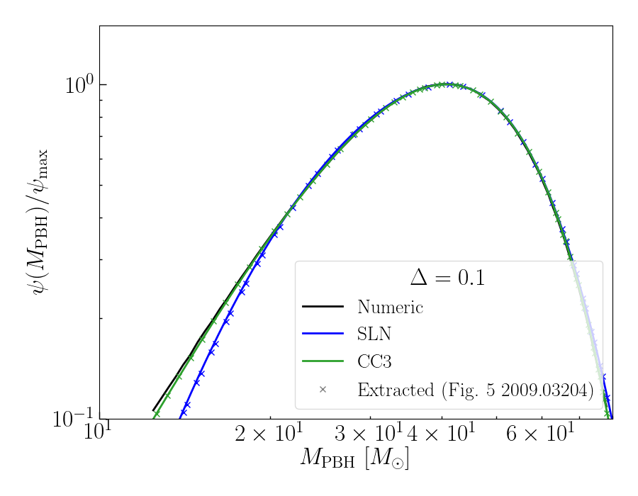

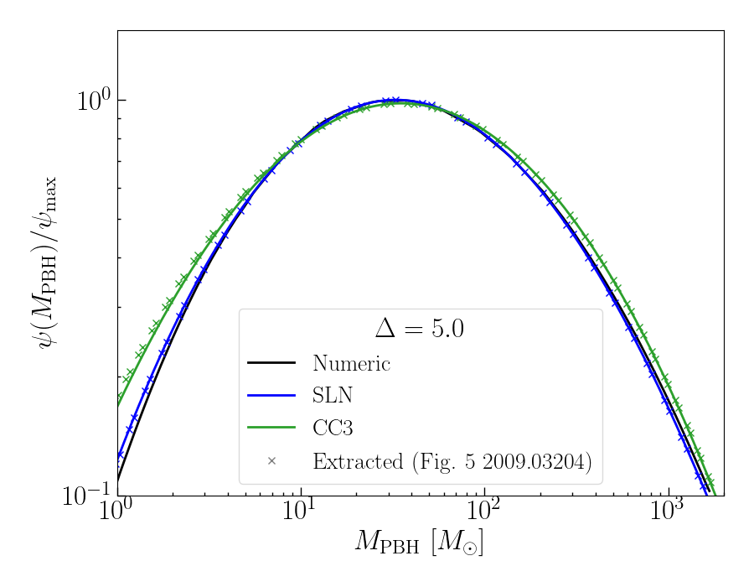

Compare peak mass of the skew lognormal with different mass ranges and numbers of masses tested, to the values from Table II of 2009.03204.

- Create array of range of number of masses to use for estimating the peak mass
  - In powers of 10, from 1e2 to 1e8?

n_steps_range = 10**np.arange(2, 8.1, 1.)

- Create array of number of sigmas to include around M_c in the estimate:
  - 1-10 ?

sigmas_range = np.arange(1, 10.1, 1.)

- Cycle through range of number of masses to use in the estimate:
  - Print the number of steps

  - Cycle through range of number of sigmas to include around M_c in the estimate:
    - Print the number of steps

  - Cycle through each value of Delta
    - For parameter values, account for the bound from the precision of the quantity given in Table II of 2009.03204.

for i in range(len(Deltas)):

print(“Delta = {:.1f}”.format(Deltas[i]))

for ln_mc in [ln_mcs_SL[i] – 0.005, ln_mcs_SL[i], ln_mcs_SL[i] + 0.005]:

for alpha in [alphas_SL[i] – 0.005, alpha_SL[i], alpha + 0.005[i]]:

for sigma in [sigmas_SL[i] – 0.005, sigmas_SL[i], sigmas_SL[i] + 0.005]:

    - Calculate estimated peak mass m_p

      - If the difference is < 0.05 M_\odot [so it agrees with values to 3SF]:

if abs(mp_calculated – mp_SL[i]) < 0.05:

        - print “Success”
        - Calculate and print fractional difference

frac_diff = abs((mp_calculated – mp_SL[i]) / mp_SL[i])
print(“Fractional difference = {:.5f}”.format(frac_diff))

To address:
- Regardless of the values of n_steps and log_m_factor, I can’t get the Delta=0.3, 0.5 values to match to within +/- 0.05 M_\odot of the values in Table II.

Compare peak mass of the skew lognormal with different mass ranges and numbers of masses tested. [INITIAL IMPLEMENTATION]

- Set required fractional precision
  - Start with 1e-5?

- Print precision

- Set value of M_c
  - m_c = 1?

- Minimum range of sigmas and number of steps to include in estimate:

sigma_range_min = max(sigmas_range) * np.ones(len(Deltas))
n_steps_min = max(n_steps) * np.ones(len(Deltas))

- Calculate the most precise estimate for the peak mass (“mp_best_estimate”)
  - i.e. using the maximum number of steps, and the widest mass range

- Cycle through each value of Delta

For i in range(len(Deltas)):

  - For parameter values, use central values loaded from Table II of 2009.03204.

  - Cycle through range of number of masses to use to estimate the peak mass:

For n_steps in n_steps_values:

    - Cycle through number of sigmas to choose around m_c when estimating:

For sigma_range in sigmas_range:

      - Print the number of steps

      - If the factional difference is smaller than the precision set

        - Print number of steps

        - Print number of sigmas used for range

        - Print fractional difference

        - Assign sigma_range_min[i] = sigma_range

        - Assign n_steps_min[i] = n_steps

        - Break (to give the minimum number of steps required and minimum range for a given precision of the M_p calculation)

Needs sanity checks

FURTHER METHODS:

- Load_results_Isatis_mono(modified=True)
  - Read in constraints on f_PBH, obtained using Isatis, with a monochromatic PBH mass function.
  - Fill in and work out details of method
  - modified: Boolean
    - If True, use data from the modified version of Isatis. The modified version corrects a typo in the original version on line 1697 in Isatis.c which means that the highest-energy bin in the observational data set is not included. Otherwise, use the version of Isatis containing the typo.
    - The default is True.
  - Returns
    - constraints_names: Array-like
      - Name of instruments placing a constraint on PBHs.
    - masses_Isatis: Array-like Removed, since the PBH mass is not given in the results file from Isatis.
      - PBH masses at which the constraint is evaluated.
    - f_PBH_Isatis: Array-like
      - Constraint on the fraction of dark matter in PBHs, calculated using Isatis.

- Choose path to Isatis
  - If modified, set path to "../../Downloads/version_finale/scripts/Isatis/"
  - Otherwise, set path to "../../Downloads/version_finale_unmodified/scripts/Isatis/"
- Load Isatis constraints data
- Define empty lists: constraints_names, f_PBH_Isatis
- Cycle through instrument names
  - If not all the constraints are -1 or 0:
    - Append that constraint name to constraints_names
    - Append the constraints to f_PBH_Isatis (to make an array of arrays)

- Load_results_Isatis(Deltas_index, mf=LN)
  - Read in constraints on f_PBH, obtained using Isatis, with an extended PBH mass function.
  - Fill in and work out details of method
  - Returns
    - constraints_names: Array-like
      - Name of instruments placing a constraint on PBHs.
    - masses_Isatis: Array-like
      - PBH masses at which the constraint is evaluated. Removed, since the PBH mass is not given in the results file from Isatis.
    - f_PBH_Isatis: Array-like
      - Constraint on the fraction of dark matter in PBHs, calculated using Isatis.

- Define variable with the path to Isatis ("../../Downloads/version_finale/scripts/Isatis/")
- Choose file name of data to load, depending on the mass function
  - if m_f == LN:
    - filename = “results_photons_GC_LN_Delta={:.1f}”.format(Delta[Deltas_index])
  - if m_f == SLN:
    - filename = “results_photons_GC_SLN_Delta={:.1f}”.format(Delta[Deltas_index])
  - if m_f == CC3:
    - filename = “results_photons_GC_CC3_Delta={:.1f}”.format(Delta[Deltas_index])
- Load Isatis constraints data
- Define empty lists: constraints_names, f_PBH_Isatis
- Cycle through instrument names
  - If not all the constraints are -1 or 0:
    - Append that constraint name to constraints_names
    - Append the constraints to f_PBH_Isatis (to make an array of arrays)

31/3: moved to extended_MF_checks.py

MAIN BODY OF PROGRAM:

Compare Isatis constraints to those shown in Fig. 14 of 2201.01265.

?? Do I run Isatis from here?
- No, I’m running BlackHawk and Isatis from isatis_runner.py

Monochromatic mass function, unmodified version of Isatis.

- Load constraints from Isatis (monochromatic MF, unmodified MF)

- Load constraints from Fig. 14 of 2201.01265

- Plot both sets of constraints on the same axes
Fig. 14: Represent with solid lines
Isatis calculation: Represent with crosses

31/3: simiilar check in extended_MF_checks.py

Estimate required mass range for each value of Delta, for calculating constraints using Isatis and the Carr et al. method

- Choose value of m_c
  - m_c = 1

- Set cutoff value on psi(M) / psi(M_max):
  - 1e-2?

- Print cutoff value

- Set number of steps to try (in log space)
  - 10000?

- Set number of orders of magnitude around the peak mass or characteristic mass to include in estimate
  - log_m_range = 2

- Cycle through values of Delta

  - Assign lower and upper masses of the range

  - Range of values of the PBH mass to use to estimate for the cutoff

  - Estimate maximum value of the mass function

  - Calculate mass function (scaled to its maximum value) at the PBH masses to use to estimate the cutoff

  - Assign lower mass to the minimum value where the mass function is larger than the cutoff, and print

  - Assign upper mass to the maximum value where the mass function is larger than the cutoff, and print

- Save .txt file with corresponding minimum and maximum values for each value of Delta.

Make the range of values to include (the \pm 3) a variable?
Make this into a method?

Why are the log-normal minimum masses clustered at the minimum possible value, when from Fig. 5 of 2009.03204 they should be at higher masses than the CC3 or SLN MF
The functional form of LN() for the log-normal mass function was incorrect. Now fixed.

Check: Using a cutoff value of 0.1, and peak masses close to the compare to the results shown in Fig. 5 of 2009.03204

- For Delta=0.1 and Delta=2.0, I have extracted the data points using WebPlotDigitizer and therefore can estimate the values at which psi / psi_max = 0.1 for the different mass functions

Delta=0.1
- Using n_steps =1000000, log_m_range = 2, cutoff = 0.1

From Fig. 5 of 2009.03204:
- Notation:
  - “M_min” = PBH mass where psi/psi_max = 0.1
  - “M_max”= PBH mass where psi/psi_max = 0.1
  - “Fig. 5” = from Fig.5 of 2009.03204, estimated using WebPlotDigitizer
  - “estimated” = estimated from the code outlined above
- All masses in solar masses
- Values given to 2SF, reflecting the accuracy possible given the width of the line in Fig. 5 of 2009.03204

 | M_min (Fig. 5) | M_min (estimated) | M_max (Fig. 5) | M_max (estimated)
LN | 17 | 24 | [off figure]
SLN | 14 | 14 | [off figure]
CC3 | 12 | 12 | 79 | 79

- The results agree very well for the SLN and CC3 where the results are calculable.
- Less good agreement for the LN MF. However, I do not have the best-fit value of M_c for the log-normal. I am estimating this using the peak mass from the SLN MF and using m_c = m_p * exp(sigma^2) for a log-normal.

Delta = 2.0
- Using n_steps =1000000, log_m_range = 2
- Values given to 2SF, reflecting the accuracy possible given the width of the line in Fig. 5 of 2009.03204

 | M_min (Fig. 5) | M_min (estimated) | M_max (Fig. 5) | M_max (estimated)
LN | 6.1 | 9.8 | 260 | 400
SLN | 5.7-5.8 | 5.7 | 260 | 260
CC3 | 5.8 | 5.8 | 260 | 260

- The results agree for the SLN and CC3.
- Less good agreement for the LN MF. However, I do not have the best-fit value of M_c for the log-normal. I am estimating this using the peak mass from the SLN MF and using m_c = m_p * exp(sigma^2) for a log-normal.

Check: Try different values of m_c and m_p. Check output is insensitive to the input value of m_c.
Output is the same regardless of the value of m_c and m_p for the vast majority of cases.

Example:
- Using n_steps =1000000, log_m_range = 2, cutoff = 0.1

Delta = 0.0 (m_c = mc_LN = m_p = 50):
Scaled mass range where psi/psi_max > 1.0e-01:
LN: [0.38966697 1.94003823]
SLN : [0.22326947 1.27984715]
CC3 : [0.3054397 1.91744221]

Delta = 0.0 (m_c = mc_LN = m_p = 1):
Scaled mass range where psi/psi_max > 1.0e-01:
LN: [0.38966697 1.94003823]
SLN : [0.22326947 1.27984715]
CC3 : [0.3054397 1.91744221]

Example:
- Using n_steps = 1000000, log_m_range = 4, cutoff = 1e-3

Delta = 0.0 (m_c = mc_LN = m_p = 1e20):
Scaled mass range where psi/psi_max > 1.0e-03:
LN: [0.21653661 3.49118243]
SLN : [0.09475867 1.89826254]
CC3 : [0.06537125 2.64238699]

Delta = 0.0 (m_c = mc_LN = m_p = 1):
Scaled mass range where psi/psi_max > 1.0e-03:
LN: [0.21653661 3.49118243]
SLN : [0.09475867 1.89826254]
CC3 : [0.06537125 2.64238699]

Delta = 2.0 (m_c = mc_LN = m_p = 1e20):
Scaled mass range where psi/psi_max > 1.0e-03:
LN: [ 0.01910321 11.76253884]
SLN : [0.00990016 7.61947208]
CC3 : [ 0.03232321 24.24093598]

Delta = 2.0 (m_c = mc_LN = m_p = 1):
Scaled mass range where psi/psi_max > 1.0e-03:
LN: [ 0.01910321 11.76253884]
SLN : [0.00990016 7.61947208]
CC3 : [ 0.03232321 24.24093598]

____________________________________________________________________________

17/3

Calculating the PBH mass range to include when calculating constraints: generalise to other measures of what quantity is non-negligible over the mass range.

METHODS:

- integrand_measure (m, m_f, params) INITIAL IMPLEMENTATION
  - Approximate form of the integrand appearing in Eq. 11 of 2201.01265.
  - m:
    - Array-like. PBH mass.
  - m_c :
    - Float. Characteristic PBH mass (m_c for a (skew-)lognormal, m_p for CC3).
  - mf:
    - PBH mass function.
  - params:
    - Array-like. Parameters of the PBH mass function.
  - Returns:
    - Array-like: PBH mass function divided by mass cubed, scaled so that the maximum value is one.

Checks:

Plot the quantity psi(M) / M^3, to understand where it peaks relative to the peak of the MF:
- Include the approximate peak mass as a vertical line
- Show different cutoff values as horizontal lines

Implementation:
- Create a wide range of PBH values (widely spaced)
  - m_pbh_values = np.logspace(np.log10(m_c) – 6, np.log10(m_c) + 4) Notice the asymmetry towards lower masses, which accounts for the fact that M^{-3} * psi(M) peaks at lower masses than psi(M).
- Plot the integrand measure on log-log plot
- Include vertical line for the characteristic mass (m_c for a (skew)-lognormal, m_p for CC3)
- Include horizontal lines for different cut-off values (1e-7, 1e-5, 1e-3)

Results:
These plots were obtained using preliminaries.py (specifically, the cell “#%% Plot the approximate form of the integrand appearing in Eq. 11 of 2201.01265, given by integrand_measure()”), accurate as of the commit https://github.com/gortonm/PBH_extendedMF/commit/f5bb35caecb307cd0af5a3e5a76794f318586dfe

For the LN MF, I am calculating M_c using the peak mass from the SLN MF, and converting it to M_c using
m_c = mp_SLN[i] * np.exp(sigmas_LN[i]**2)

- At low masses, the CC3 MF has a much more substantial tail at low-masses than the SLN or LN MFs. The tail at low masses is so large that
  - For Delta=0.0, the tail in the CC3 is so strong that the integrand is ~0.5 of its peak value when M ~ 1e-5 M_p
  - Explanation:
    - The form of the CC3 MF is approximately given by a power law for m << m_p, with exponent alpha
    - The best-fit values of alpha (from Table II of 2009.03204) for Delta <~ 0.5 are close to 3
      - Therefore, the combination psi(m) / m^3 ~ constant for m << m_p
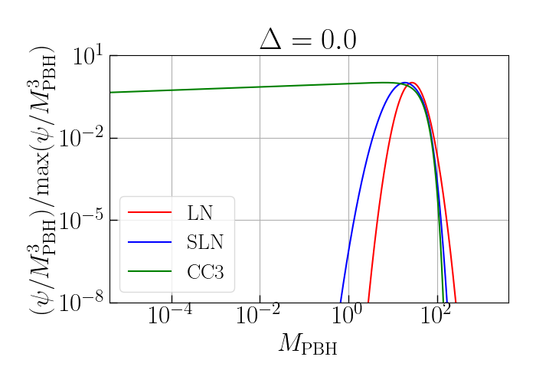

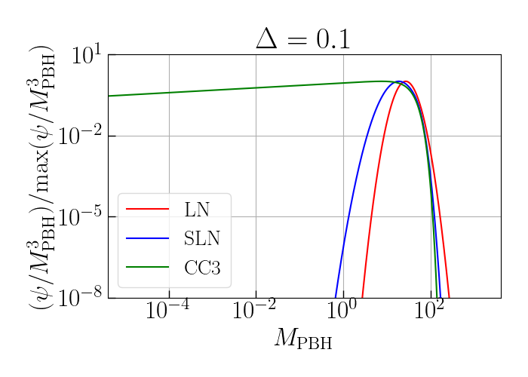

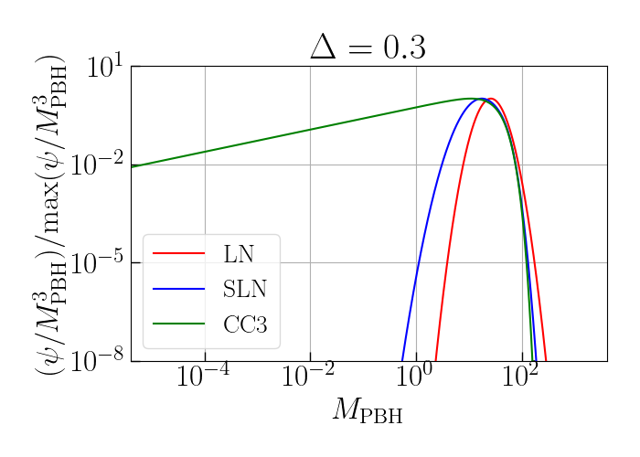
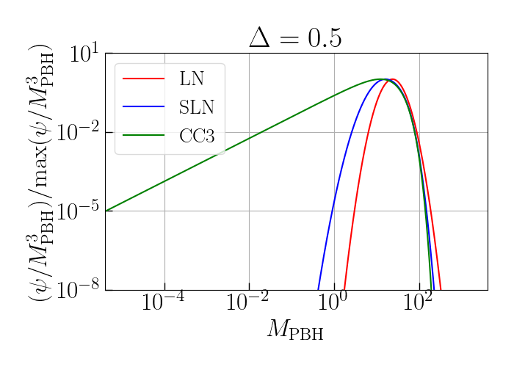

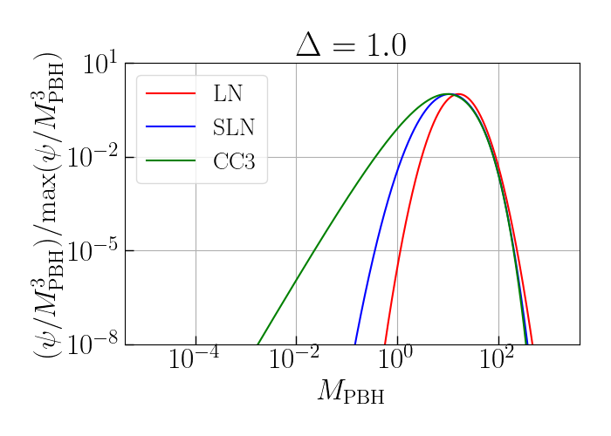

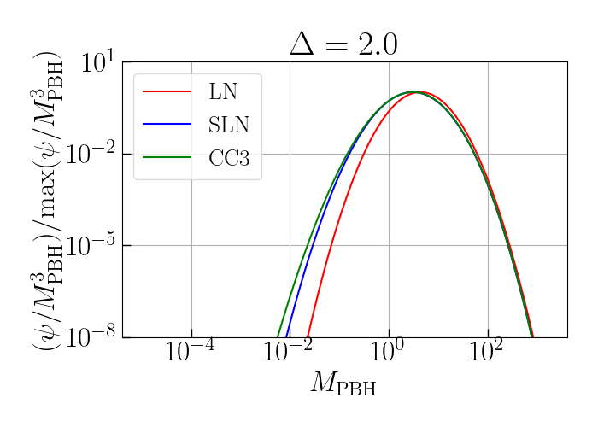

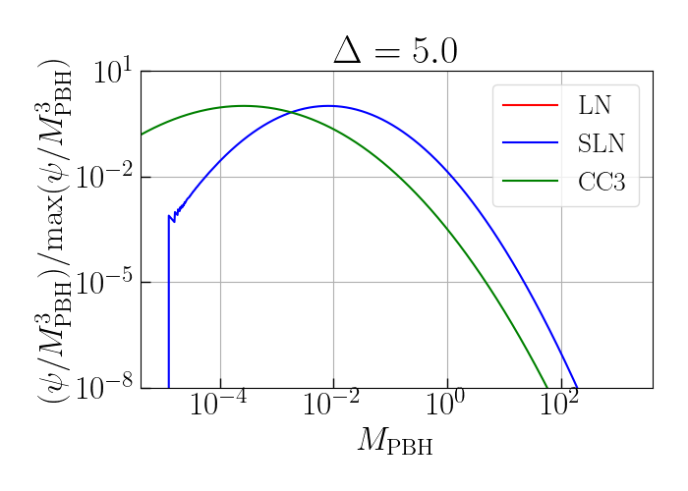
Mass function plots:
